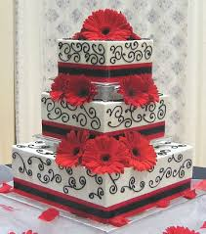
You are creating a wedding cake for a couple. The couple has already picked out a design that they like. The cake is composed of three tiers. Each tier is a square prism. The bottom tier has a length of 20 inches. The second tier has a length of 14 inches and the top tier has a length of 8 inches. Each tier has a height of 6 inches. The surface of the entire cake will need to be covered in frosting. How many cans of frosting will you need to buy, if each can covers 250 square inches?
- Calculate the surface area of the wedding cake.
- Remember, frosting will not be placed where the tiers
are connected.
- Determine how many cans of frosting you will need.
- Show work to support your answer using words,
numbers, and/or pictures.

Number of Cans: ____________________

