Name __________________ Date _______
Circumference & Area Task
Essential Question: How are circumference, area & rates related?

C=πd | C=2πr | A=πr²

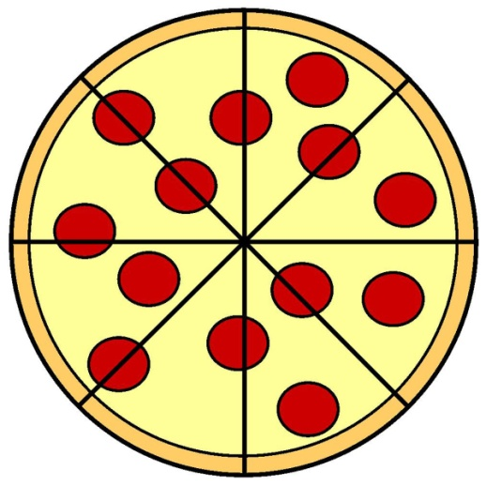
Tillman’s Pizzeria is having a sale on medium and large pizzas. Medium pizzas are 10 inches in diameter and cost $7.99. Large pizzas are 14 inches in diameter and cost $14.99.
Which size pizza is the better deal?
Hint: Find the cost per square inch of pizza
SHOW ALL WORK.

Medium Pizza: Large Pizza: Best Deal:

Regular Price Menu at Tillman’s Pizzeria:
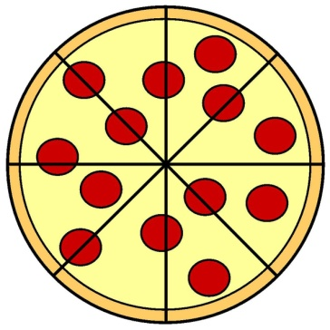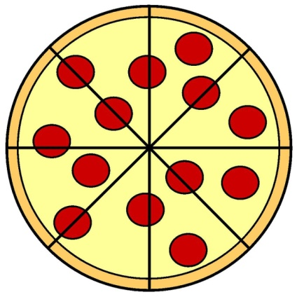
Small Medium Large
$6.99 $9.99 $15.99
d = 6 in. r= 5 in. d=14 in.
Area: __________ Area: __________ Area: __________
Circumference: _____ Circumference: _____ Circumference: _____

Price per square inch: Price per square inch: Price per square inch:
_________________ _________________ _________________

The sizes and prices for pizzas at Tillman’s Pizzeria are listed above. Find the area of each pizza. Which size would you buy if you wanted the best price per square inch? Why?

Is it more helpful to find the circumference of the pizza or the area of the pizza when you are comparing prices? Does one formula give you a different result than the other? How could you prove it?

